Unit 19. Networking overview
What This Unit Is About
This unit gives an overview of TCP/IP and networking concepts.
What You Should Be Able To Do
After completing this unit, students should be able to:
- Define the basic TCP/IP terminology
- Configure TCP/IP for an Ethernet or Token-Ring connection
- Use some of the standard TCP/IP facilities to:
- Login to another system
- Transfer files
- Run commands
- Configure TCP/IP remote printing
How You Will Check Your Progress
Accountability:
- Checkpoint questions
- Exercises

19.1 Objectives
After completing this unit, students should be able to:
- Define the basic TCP/IP terminology
- Configure TCP/IP for an Ethernet or Token-Ring connection
- Use some of the standard TCP/IP facilities to:
- Login to another system
- Transfer files
- Run commands
- Configure TCP/IP remote printing

Notes:

19.2 What is TCP/IP?
- Transmission Control Protocol/Internet Protocol
- Software to enable different systems to exchange data over a variety of types of network
- The way in which systems are connected and how data is passed between them is transparent to the user
- TCP/IP is vendor independent. Development is overseen by the "Internet Architecture Board" funded by the US Government
Notes:
- TCP/IP is a networking architecture which defines a mechanism for co-operating computers connected by some sort of network to exchange data. TCP/IP software has been implemented across many platforms from mainframes to personal computers although it is most commonly associated with UNIX/AIX workstation environments.
- TCP/IP is a set of protocols which define various aspects of how two computers on a network may communicate with each other. A protocol is a set of rules which describe the mechanisms and data structures involved. Using these definitions, vendors can write software to implement the protocols for particular systems.
- TCP/IP stands for "Transmission Control Protocol/Internet Protocol". These are the names of the two most important protocols. There are many others. Where possible, the protocols are defined independently of any operating system, network hardware or machine architecture. In order to implement TCP/IP on a system, interface software must be written to allow the protocols to use the available communications hardware.
- This means that heterogeneous environments can be created where machines from different manufacturers can be connected together, and different types of networks can be interconnected.
- TCP/IP is the result of work commissioned in 1968 by DARPA the US Department of Defence, Advanced Research Projects Agency. Many other research and vendor organizations have contributed to the development of TCP/IP.
- DARPA implemented a point-to-point network using leased lines called ARPANET using protocols which eventually evolved into TCP/IP. In 1980, ARPANET became the backbone to the “Internet” which links many US government, military, research, educational and commercial organizations.
- The main popularity of TCP/IP has been due to its association with UNIX systems. In particular DARPA funded University of California, Berkeley to integrate TCP/IP into their versions of UNIX (BSD 4.2, 4.3)
- Most TCP/IP development is initiated by an organization called the Internet Architecture Board (IAB) which oversees development of the Internet network and the TCP/IP software it uses. Other TCP/IP development is performed by vendor organizations who write protocols which may become Internet standards.
- The IAB distributes documents called Request For Comments (RFC) which describe TCP/IP protocols and other relevant information. RFCs are the primary source of TCP/IP and Internet information and are freely available in the Internet.
- There are two subseries of the RFCs of interest. The STD (standards) documents describe all of the official TCP/IP standard protocols. The FYI (for your information) documents provide useful information about TCP/IP, the Internet and running a TCP/IP network.

19.3 An Internet
- A TCP/IP network is often called an internet
- 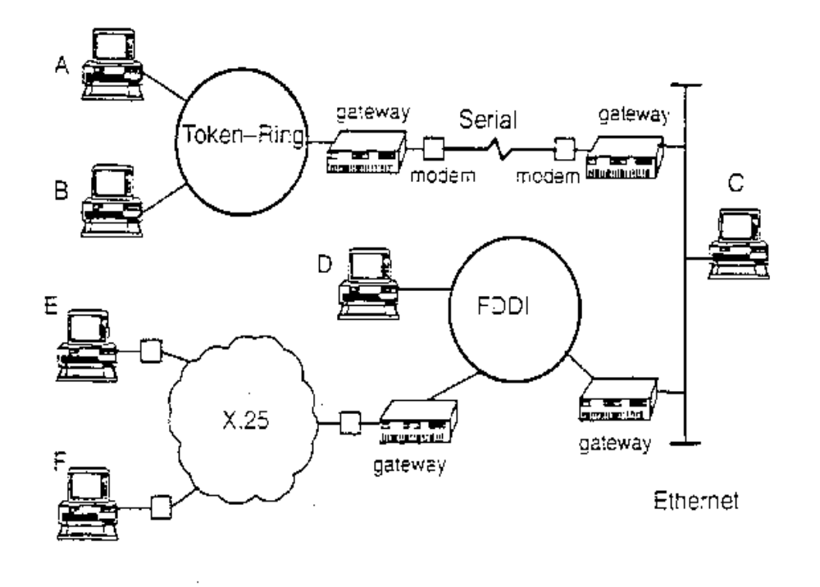Individual machines are called hosts. Hosts may vary in size and functionality but have equal standing as far as TCP/IP is concerned
- Hosts which link two or more physical network segments to each other are called gateways
Notes:
- TCP/IP works with many different types of networks from slow speed serial type connections to fast local area networks like Token-Ring or Ethernet or even faster Fiber-Optic networks like FDDI and HYPERchannel.
- Local Area Network (LAN)

- Networks in a close geographical area. Often high speeds over short distances Computers must connect directly to network media (via a transceiver or tap)
- Token-Ring (4 or 16 megabits per second)
- Ethernet (3 or 10 megabits per second)
- FDDI (100 megabits per second)
- Wide Area Network (WAN)
- Can be far apart
- Computers often connected indirectly (modems, public telephone networks)
- Generally slower speeds than LANs (up to 1.54 megabits per second)
- An internet is a term given to a number of TCP/IP networks connected together. An internet can be a combination of similar networks or heterogeneous networks. In an internet data can be transferred, transparently from one host to another without the sending host needing to know the route taken or the type or number of connections involved.
- There are a number of public Internets world-wide, the largest oil which is called “The Internet” (or the “connected Internet”). The Internet consists of over 1.000,000 connected systems with about three million users. It is primarily used for mail and file transfer.
- A host is any computer attached to the network which has a TCP/IP address. This includes machines of any size or functionality. For example, an X-Terminal is a host as far as TCP/IP is concerned. Each host is given a unique name (for users) and address (for software) so that it can be uniquely identified in the interconnection of networks.
- A host which has multiple network adapter cards is called a gateway. This can either be a dedicated machine to provide the function of routing data between networks or can be a machine providing applications as well (often called a multi-homed host). This is not often recommended because of the extra load that the routing function will add.

19.4 Names and Addresses
- Each system in a TCP/IP network is given a name
For example: sys3
- When contacting another system you only need to know the name
For example: $ telnet sys3
- When contacting another user you need to know the system and user name
For example: $ mail fred@sys3
- Each system will have one or more TCP/IP addresses
For example: 128.27.9.13
If you know the address but not the name, you can use some TCP/IP
facilities with the address
Notes:

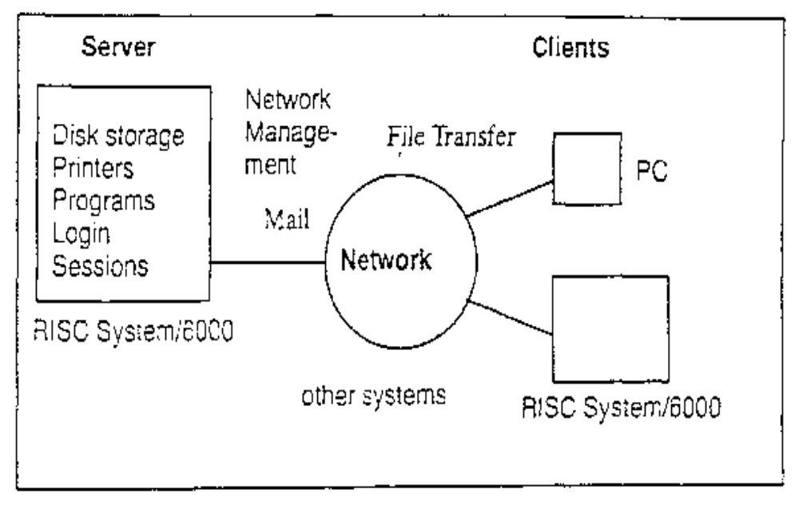19.5 TCP/IP Network Facilities

Standard TCP/IP facilities include: Mail, File Transfer, Remote Login, Remote Execution, Remote Printing
A number of AIX Applications use TCP/IP:
- Network File System (NFS)
Network Information Services (NIS)
- Network Computing System (NCS)
- Distributed Computing Environment (DCE)
- Xwindows and AIXwindows
- Xstation Manager
- AIX Netview/6000
Notes:
- There are many applications that require or can take advantage of TCP/IP. The ones listed are available from IBM either, as standard or as licensed program products. There are many third-party applications (for example databases) that can also use TCP/IP for distributed work.
- Network File System (NFS) allows access of remote files as if they were local. Network Information Services (NIS) provides a distributed database of system information.
- Network Computing System (NCS) allows applications to be written to run procedures on other system in a network.
- The Network Licensing (iFOR/LS) is part of the AIX BOS and is the mechanism to enable or activate various products that may be installed on your system.
- Distributed Computing Environment (DCE) provides a rich set of facilities for developing and running distributed applications. It is based on NCS with many other services including Security Service, Directory Service, Time Service and management tools.
- Xwindows / AIXwindows provide a distributed graphical user interface.
- Xstation Manager allows attachment of an IBM Xstation (requires AIXWindows).
- AIX Netview/6000 provides a sophisticated set of management tools for TCP/IP networks. It uses the AIXWindows environment to provide a graphical user interlace for the network manager and uses Simple Network Management Protocol (SNMP) to pass management information around the network.

19.6 Information Needed to Configure TCP/IP

19.6.1 Addresses
- Each adapter is given a unique TCP/IP address and often a subnet mask. These will usually be assigned by your network administrator

19.6.2 Names
- Each machine has a unique hostname
- Each machine must have access to a table of name to address translations. This can be either:
- /etc/hosts file
- Domain Name Server - You must know:
- Domain Name
- Address of the Name Server
- Routes
In order to communicate with systems in other networks, you may need to find out the address of the default gateway

Notes:
- Each system in a TCP/IP network must have a unique TCP/IP address and hostname. Your network administrator will centrally manage tables of names and addresses and will assign these for your system. On some networks a subnet mask is also required which is used to determine which network your machine belongs to for routing purposes.
- Each host in a network is allocated a name which the users find easier to remember. However, the TCP/IP protocols can only use TCP/IP addresses when sending data. Therefore a portion of TCP/IP is responsible for translating the symbolic host names into TCP/IP addresses. This process is called name resolution.
- There are two separate mechanisms defined for name resolution:
- Flat Network
- Each host in the network has a record of the name and address of every other host it will communicate with. This is in a text file called /etc/hosts.
- This is quick but becomes difficult to administer if there are a large number of hosts.

- Domain Network (Domain Name System)
- Hosts are grouped together into domains which form a hierarchy (similar to the file directory structure). One (or more) hosts in a domain (called nameservers) have a record of the name and address of all hosts. Client hosts request name to address translations from a nameserver. Use the /etc/resolv.conf file.
- There may be more than one name server in a domain network for backup, but only one will have the primary copy of the database on its local disk. Clients only need to know the domain name and the address of the nameserver(s). This mechanism is much more suitable for large networks because administration is centralized on a few machines.
- If your network is just part of a larger network then you will need to know about the gateway machines which link your network to others. Most network designs will only have one gateway called the default gateway. You will need to know the address of the default gateway to allow your system to communicate with other systems through the gateway .

19.7 Configuring TCP/IP - Classical RISC System/6000
# smit mktcpip
- Token-Ring Speed 4 or 16 Mbits/s
Minimum Configuration & Startup
To Delete existing configuration data, please use Further Configuration menus
Type or select values in entry fields.
Press Enter AFTER making all desired changes.
[Entry Fields]
* HOSTNAME [sys1]
* Internet ADDRESS (dotted decimal) [192.9.200.1]
Network MASK (dotted decimal) [255.255.255.0]
* Network INTERFACE tr0
NAMESERVER
Internet ADDRESS (dotted decimal) []
DOMAIN Name []
Default GATEWAY Address []
(dotted decimal or symbolic name)
RING Speed 4 +
START Now no +
F1=Help F2=Refresh F3=Cancel F4=List
F5=Reset F6=Command F7=Edit F8=Image
F9=Shell F10=Exit Enter=Do

- Ethernet connector bnc or dix
Notes:
- When the TCP/IP software is installed, a new menu called “TCP/IP” (fastpath: tcpip ) is added to SMIT in "Communications Applications and Services” and other places.
- The SMIT “Minimum Configuration & Startup” option (fastpath: mktcpip) or the mktcpip command can be used to quickly configure TCP/IP on the RISC System/6000. This initializes TCP/IP (for client services) but further customization will be required.
- The minimum information that is required to start TCP/IP is the hostname, and one interface and it's internet address. If subnetting is used then the subnet mask should be specified. A static route can be specified to a default gateway. Also the domain name and name server for a client in a domain network can be specified.
- You can decide whether to start the TCP/IP daemons when initializing TCP/IP through this option.
- The "Further Configuration" menu (fastpath: configtcp) contains a series of menus for customizing TCP/IP options. For example, hostnames, routes, interfaces, name resolution, server and client services.

19.8 Flat Name Resolution
# more /etc/hosts
# The format of this file is:
# Internet Address Hostname # Comments
# Items are separated by any number of blanks or tabs. A"#"
# indicates the beginning of a comment; characters up to the end of the
# line are not interpreted by routines which search this file. Blank lines are
# allowed in this file.

# Internet Address
Hostname # Comments
192.9.200.1 sys1 timeserver
      - sys2
      - sys3
      - sys4
127.0.0.1 loopback localhost

Notes:

19.9 Configuring TCP/IP - PCI RISC System/6000
- Configuring TCP/IP on a PCI RISC System/6000 includes the following configuration steps:
- Configure the ISA adapter
- Configure the network interface
- Complete TCP/IP configuration
Notes:
ISA adapters must first be configured on the system as a device and then it must be made available to the system. Once this is done, the network interface supporting the adapter is configured. Finally, completion of TCP/IP configuration is performed to interact with other systems in the network.

19.10 Configuring an Ethernet ISA Adapter to AIX
# mkdev –c adapter –s isa –t ethernet –a bus_intr_lvl=11\
>-a bus_io_addr=0x300 –a bus_mem_addr=0xc8000\
>-a media_type=bnc –p busl
ent0 Available
Notes:
- This example is the configuration of an Ethernet card. The values shown on the visual match the hardware parameters set on the card at the time of installation. Your values may or may not be the same. This information can be obtained from the System Management Services diskette by selecting:
- ―Utilities
- ―Remote Initial Program Load Setup
- ―Adapter Parameters
- ―IBM LAN Adapter for Ethernet
- ―View or Set Parameters
- Following are some of the valid choices for IRQ, I0, MEM, and TYPE for Ethernet:
- ―IRQ is the interrupt level (5, 7, 9 or 11)
- ―IO is the I/O address (0x240, 0x280, 0x300...)
- ―MEM is the shared memory address (0X000, 0x4000, 0xc8000,…)
- ―TYPE is the type of cable connecting you will be using (bnc, dix, tp)
- Note: The shared memory address for Ethernet, MEM, will always show OE4000 when viewing these values from the System Management Services diskette. This value cannot be used as a valid MEM parameter. Select one listed from the list above or from the manual, Managing AIX V4 on PCI-Based PISC System/6000 Workstation (SG24-2581), which contains a suggested parameters value chart for ISA adapters. You CANNOT change the value of the shared memory address from the System Management Services diskette. It can only be changed when defining it to AIX.
- If the card is an ISA Token Ring card the parameters would be:
- # mkdev -c adapter -s isa -t tokenring -a intr_level=IRQ \
- >-a bus_io_addr=IO -a shared_mem_addr=MEM \
- >-a shared-mem_leng=LEN -a bios_addr=BIOS \
- >-a ring_speed=SPEED -p busl
- where:
- ―IRQ is the interrupt level (3, 6, 7 or 9)
- ―IO is the I/O address (0xa20, 0xa24,....)
- ―MEM is the shared memory address (Oxd0000, Oxc0000,…)
- ―LEN is the length of the shared memory (OX8000, Ox10000,…)
- ―BIOS is the ROM memory address (Oxdc000, Oxcc000,…)
- ―SPEED is speed of the network ring (16, 4)
- If this is the ONLY communications adapter card that will be installed on your system, the card can be configured through SMIT by selecting Devices, ISA Adapters, Add an ISA Adapter. The SMIT method will use the default values in the predefined database. If you want to be sure that you won't have conflicts with other cards that may be installed later, use the mkdev command.

19.11 Configuring the Network Interface
# smit mkinet
Add a Standard Ethernet Network Interface
Type or select values in entry fields.
Press Enter AFTER making all desired changes.
[Entry Fields]
* INTERNET ADDRESS (dotted decimal) [192.9.200.1]
Network MASK (hexadecimal or dotted decimal) [255.255.255.0]
Network INTERFACE en0
* ACTIVATE the Interface after Creating it? yes
Use Address Resolution Protocol (ARP)? yes
BROADCAST ADDRESS (dotted decimal) [ ]

F1=Help F2=Refresh F3=Cancel F4=List
F5=Reset F6=Command F7=Edit F8=Image
F9=Shell F10=Exit Enter=Do

Notes:
- Once the adapter is available, you must configure the network interface. In this example, you are making en0 available.
- To get to this menu without using the smit fastpath command, do the following:
# smit
- Communications Applications and Services
- TCP/IP
- Further Configuration
- Network Interfaces
- Network Interface Selection
- Add a Network Interface
- Select –Add a Standard Ethernet Network Interface
- From the pop-up box, select en0

19.12 Completing TCP/IP Configuration
- Edit /etc/hosts to add the host names and IP addresses for all system you want to communicate with on the network
- Set the host name

Notes:
- You can use SMIT or vi to add entries to etc/hosts. The Hosts Table menu (fastpath: hosts) contains options to list/add/change/delete hosts in the /etc/hosts file. To get to this menu from the TCP/IP menu, select Further Configuration then Name Resolution.
- Host names and their Internet addresses are mapped by entries in the /etc/hosts file. In a flat network, the file should have entries for the local system name, local host, and for all other hosts known to the system. Typically, /etc/hosts is kept consistent between all systems.
- In a domain network, the /etc/hosts file can be empty; although, some hosts can be added for access to other hosts, if the name server is down.
- The host name can be set using the hostname command. For example, # hostname sysl
- Setting the host name from the command line sets the host name in memory only. At the next system start, this host name will not be set. Use the command smit hostname to set the name so it is retained after a system startup.

19.13 Basic TCP/IP User Functions
The following commands word with any TCP/IP system (not just UNIX/AIX):
- Test connectivity ping
- File Transfer ftp
- Remote Login telnet
- Remote Execution rexec
Notes:
- The ARPA commands for File Transfer, Remote Login and Remote Execution are ftp, telnet, rexec respectively.
- These commands can be used between any TCP/IP system that supports the appropriate protocols, not just UNIX/AIX systems.
- In order to ensure security across the network, these commands will always require a user name and password to be supplied when you establish a connection.
- ping - Tests connectivity with another system
- $ ping sys2
- PING sys2:(192.9.200.2): 56 data bytes
- 64 bytes from 192.9.200.2: icmp_seq=0 ttl=255 time=l5 ms
- 64 bytes from 192.9.200.2: icmp_seq=l ttl=255 time=3 ms
- 64 bytes from 192.9.200.2: icmp_seq=2 ttl=255 time=2 ms
- 64 bytes from 192.9.200.2: icmp_seq=3 ttl=255 time=2 ms
- 64 bytes from 192.9.200.2: icmp_seq=4 ttl=255 time=2 ms
- ^ C
- ━━ sys2 PING Statistics ━━
- 5 packets transmitted, 5 packets received, 0% packet loss
- round-trip min/avg/max = 2/4/l5 ms
- $

- rexec - Run a command on another system
- Cannot run interactive commands
- Cannot run commands that run full screen
- sys1 rexec sys2 uname -x
- Name (sales2:tom): tom
- Password: tom's password
- AIX sys2 526332 2 3 000003F41C00
- sys1$_
- The rexec command executes a command on another host. The command formal is:
- rexec host command
- If the command contains metacharacters for the remote system, they must be enclosed in quotes.
- The ftp command is used to transfer files from one system to another, it is normally an interactive environment and it provides a number of commands for transferring files. It can also be used for batch operation.
- ftp will require you to specify a user and password to establish a connection to the remote system. This userid and password can be stored in a file in your home directory called .netrc. You can also specify automatic login procedures in this file.
- Typical tasks that can be carried out are:
- List/Transfer/Delete Local/Remote Files
- Change Current Local/Remote Directory
- Create/Remove Directories
3) For example:
- sys1$ ftp sys2
- connected to sys2
- 220 sys2 FTP Server ready.
- Name (sys2:smith): user1
- 331 Password required for user1
- Password (sys2:user1): user1's password
- 230 User user1 logged in
- ftp> binary
- 200 Type set to I
- ftp> put file1 /tmp/f1
- 200 PORT Command successful.
- 150 Opening data connection for /tmp/f1 (192.9.200.1,1016)
- 226 Transfer Complete.
- 308310 bytes sent in 3.58 seconds (85.71 Kbytes/s)
- ftp> quit
- 221 Goodbye.
- sys1$_
4) There are many ftp subcommands. To obtain a list use ? or help.
- To get help on an individual subcommand use ? subcommand or help subcommand For example:
- ftp> help open
- open connect to remote ftp
- ftp>
- To find out what commands are supported on the remote host use rhelp or
remotehelp.
- telnet - Remote Login (telnet)
- sys1$ telnet sys2
Trying ...
Connected to sys2.
Escape character is ‘^]’.
- AIX telnet (sys2)
- login: tom
password: tom's password
:
:
sys2$ ^]
telnet> ?
- The telnet command implements the client end of the TELNET protocol
for remote login.
- If you are running telnet from one AIX/UNIX system to another, your terminal type will be passed correctly. Otherwise, you will have to set the TERM variable after you login.
- The Escape character (usually ^]) allows you to escape into a telnet menu from which you can execute local commands or manage connections.
- You can use the ^] key to escape to a telnet menu from which you can enter subcommands. .
- Use ? or help to list the available subcommands:
- You can open or close connections and manipulate connection settings.
- Use z to execute a shell on the local host.

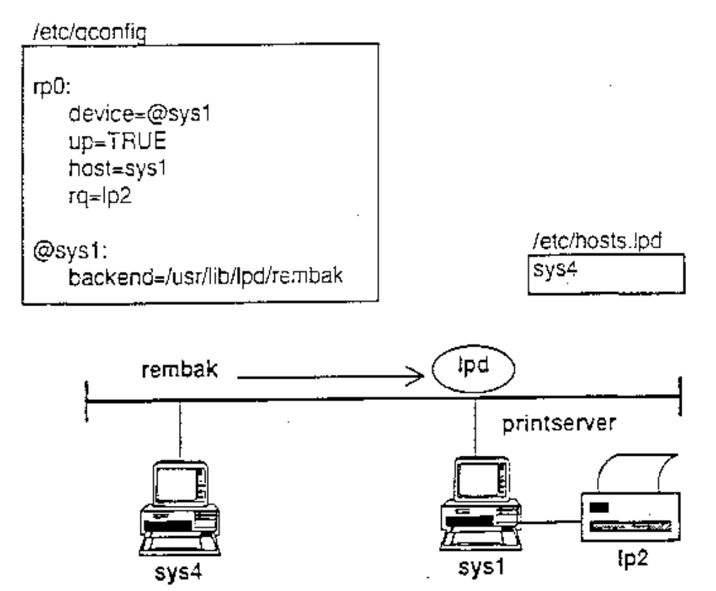19.14 Remote Printing
# qprt -Prp0 file
Notes:
- As far as the client goes, remote printing works in the same way as local printing. The user still uses one of the printer commands to submit a job. The only difference is the backend process. Instead of printing to an attached printer, the backend opens a TCP/IP connection to a server process and assuming it is authorized, it will transfer the file to a queue on the destination.
- On the server, a daemon called lpd runs, which allows remote systems to print on a local printer. The system which has the printer is called the printserver.
- On the printserver, the printer should be setup for normal local printing and the lpd daemon should then be run to handle requests from remote clients. Each client request is validated as to whether it has permission to print on the server.
- The file /etc/hosts.equiv could be used in place of /etc/hosts.lpd. Be careful about the security issues with this file.

19.15 Print Server Setup

19.15.1 Add printer as normal for local use

19.15.2 Start lpd daemon
- Started from /etc/rc.tcpip
- Either edit file or use SMIT to enable

19.15.3 Authorize hosts in /etc/hosts.lpd
- Lists hosts that can print on your printers
- No limit to what printers they can access
- Either edit file or use SMIT to enable
Notes:
- On the printserver, the printer and queue are added as normal for local operation.
- The line printer daemon (lpd) must be running. It:
- lpd is started by uncommenting the appropriate lines in /etc/rc.tcpip. Use the SMIT Manage Print Server under the Print Spooling menu.
- In order for a host to be able to print on your local system, it must be listed in the /etc/hosts.lpd file. Also hosts listed in the /etc/hosts.equiv file will also be authorized for remote printing. Either edit the file directly, or use the SMIT "Host Access for Printing" menu to perform this function.

19.16 Client Setup
Define remote queue in /etc/qconfig
# smit mkpq
Add a Print Queue
Move cursor to desired item and press Enter, Use arrow key to scroll.
# ATTACHMENT TYPE DESCRIPTION
local Printer Attached to Local Host
>>> remote Printer Attached to Remote Host
xstation Printer Attached to Xstation
ascii Printer Attached to ASCII Terminal
hpJetDirect Network Printer (HP JetDirect)
file File (in /dev/directory)
other User Defined Backend
F1 = Help F2 = Refresh F3 = Cancel
F8 = Image F10 = Exit Enter = Do
/ = Find n = Find Next

Type of Remote Printing
Move cursor to desired item and press Enter.
>>> Standard processing
Standard with NFS access to server print queue attributes
Local filtering before sending to print server

Notes:
- To get to the Add a Print Queue menu, you have to select the Print Spooling option from the main SMIT menu.

19.17 Adding a Standard Remote Queue
Adding a Standard Remote Queue
Type or select values in entry fields.
Press Enter AFTER making all desired changes.
[Entry Fields]
* Name of QUEUE to add [rp0]
* HOSTNAME of remote server [sys1]
* Name of QUEUE on remote server [lp2]
TYPE of print spooler on remote server AIX Version 3 or 4 +
DESCRIPTION of printer on remote server [ ]

F1=Help F2=Refresh F3=Cancel F4=List
F5=Reset F6=Command F7=Edit F8=Image
F9=Shell F10=Exit Enter=Do

Notes:
- Each host that wants to submit jobs for remote printing must define a print queue for the remote jobs.
- The queue must specify the destination host and remote queue and the remote backend program.
- To do this use the SMIT Add a Remote Queue menu to set up the remote queue in /etc/qconfig. Enter the queue name, queue device name (usually the same as the queue name), destination host and queue.
- The remote backend program (rembak) is called by the qdaemon when a file is queued (to a remote printer) with the printer commands (qprt/lpr/lp). The backend sends the print request to the lpd daemon on the remote printserver.

19.18 Printing On a Remote Printer
Standard AIX printer commands are used, and they also use the queue mechanism

19.18.1 To print a file to the remote queue:
$ qprt –Prp0 letter.doc

19.18.2 To list files in local and remote queue:
$ qchk –Prp0
Queue Dev Status Job Files User PP % Blks Cp Rnk
rp0 ldev READY
lp2 lp0 RUNNINC- 256 letter.doc john@sys1 0 3 6222 1 1

19.18.3 To cancel remote print jobs:
$ qcan –Prp0 -x 256

Notes:
- To print on a remote printer the user enters:
- $ qprt –Prp0 filea
- (The lp and lpr commands will also work.)
- When you use qchk (or lpstat/lpq) to list the queues, a listing of the queue on the remote printer will be displayed in addition to the list of files queued on the local system for the remote printer.
- To cancel a print file you must specify both the remote queue name and the job number on the remote system. This is because job numbers are only unique for the local system. You can only cancel print jobs that you submitted. For example,
- $ qcan –Prp0 256
- Note that all the supported print commands can be used.

19.19 Checkpoint
Exercise - Networking Overview
1. What are the following commands used for?
- ftp
- rexec
- telnet
2. What is the difference (if any) between a host and a gateway?
3. Each machine in a TCP/IP network must have a unique hostname and
TCP/IP address. True or False?
4. Which file holds the name and the TCP/IP address of each host?

19.20 Unit Summary
- TCP/IP is a networking architecture which defines a set of rules. These rules describe how computers can communicate with one another over a network
- A flat TCP/IP network can be configured through SMIT by supplying the following information: addresses, subnet mask and hostnames
- There are many useful utilities which are provided by TCP/IP, such as telnet to login to another system, ftp to transfer files and rexec to execute a command on a remote system
- Another facility available is remote printing which enables print jobs to be serviced on a remote system

